**Senior Care Management System Database**

Course: CSC8230

Submitted By: Saumya Sucharita Behera

**Introduction**

The U.S. population is aging. Today, there are more than 46 million older adults age 65 and older living in the U.S.; by 2050, that number is expected to [grow to almost 90 million](https://assets.prb.org/pdf11/aging-in-america.pdf). This means by 2030, [1 in 5 Americans](https://www.census.gov/content/dam/Census/library/publications/2015/demo/p25-1143.pdf) is projected to be 65 years old and over. (Source: [Demographic Changes and Aging Population – RHIhub Aging in Place Toolkit (ruralhealthinfo.org)](https://www.ruralhealthinfo.org/toolkits/aging/1/demographics#:~:text=Today%2C%20there%20are%20more%20than,increase%20by%20almost%2018%20million.). With the increasing aging population, the current healthcare system in the United States is not equipped to deal with increasing senior care. The costs associated with professional senior care can be unjustifiable for many families who would wish to utilize it. This renders many families to care for their elderly family members themselves. Senior care maangement system is developed keeping in mind the needs of the senior patients as well as their caretakers who can be patients themselves.

**Proposed Solution**

This project aims to design a senior patient portal in conjunction with a few OpenEMR tables.

* Helps seniors keep track of their major illnesses like diabetes, high blood pressure, memory issues, physical problems, etc.
* Helps families in keeping track of care for their aging loved ones:
  + Manage medications
  + Set reminders for doctor appointments, lab work appointments
  + Get reminders for medications as per the frequency set by the user
* Add/Remove caregivers according to the senior’s changing needs
* Senior patients can limit access to their diagnosis information, medication information with the caregivers if they are not comfortable sharing those details
* Find assisted living facilities/nursing homes near the patient

1. **Medication and appointments tracking:**

Brief description of the tables outlining the main information contained in it:

**Patient_data** – Contains the patient demographic information(Imported from OpenEMR)

**Icd10_dx_order_code** – Contains all the ICD10 diagnosis codes.(Imported from OpenEMR)

**Patient_diagnosis –** Contains the current diagnosis of the patient. It has the primary and secondary ailments along with which doctor diagnosed it and when it was diagnosed. It can have details such as when the diagnosis was cancelled and who cancelled it.

**Caregivers_master –** This table has all the details regarding the caregiver such as their name, birth date, gender, contact number, email id. A caregiver herself can be a patient. So, **‘**Caregiver_pid’ is a foreign key to the patient id in patient_data table.

**Patient_Caregiver –** This is a relational table between the patient and caregiver. This table stores information of all the caregivers a patient has. It has details like when the caregiving started and when the caregiving term ended for that caregiver-patient combination. The patient can choose to share her diagnostic and medication details with this particular cargeiver.

**Physician_details –** This table contains information of the physicians associated with a particular patient. It has their first name, last name, contact details, address and next appointment date time with the physician.

**Medications_patient –** This table contains the details of all medications a senior patient has. It contains the medication name, dosage, specific instructions and medication intake start time for a given medication. PrescribedByPhysicianID is a foreign key which references the Physician_Id in the Physician_details table. This table has the frequency(daily, weekly, etc) and the time interval at which the medication is supposed to be repeated. It helps us in calculating the next intake time of the medicine for that patient.

**Medication_reminders_patient –** Medications_patient and Medication_reminders_patient table has a 1:N relationship. For a single medication, we can have multiple instances of reminders. Depending on the frequency and repeat_interval of a medication in Medications_patient a scheduled_time is set in this table. Along with the scheduled_time, this table contains the medication_id, dosage of the medicine. A patient/caregiver can set the status of the reminder as ‘Pending’, ‘Taken’, ‘Skipped’ or ‘TakeLater’.

If the patient chooses to take the medicine at a later date time, there is a Rescheduled_time set in the table. Status_validated_by is a foreign key which references either the pid in patient_data table or the caregiver_id in the patient_caregiver table.

**Doctor_appointment** – This table contains the doctor appointment details a patient can have. It contains the physician name, appointment date, reason of visit and address of the appointment.

**Lab_order_details** – Order_id and pid form the composite primary key for this table. This table contains the details of a particular lab order provided by the physician. OrderedBy_PhysicianID is a foreign key which references the Physician_Id in the Physician_details table. It contains the laboratory name, address and the ordered date for a lab order.

**Laboratory_appointment** – This table contains the details of a laboratory appointment for a particular patient. It has the laboratory name, appointment date and address of the given lab.

**Reminders** – When a patient sets up a doctor/laboratory appointment, an instance of a reminder is created in this table. Reminder_id is the primary key. Rem_time is the time at which the reminder is generated. It is a foreign key referencing Reminder_datetime in both doctor_appointment and laboratory_appointment tables.

1. **Find assisted living/nursing homes near patient**

When seniors are not fully capable of taking care of themselves, they may look out for assisted living facilities nearby their location. Assisted living communities are designed for older adults who are not sick enough for a hospital, but who may have some chronic medical conditions that need monitoring. These residents also often need help with bathing, dressing, housekeeping, toileting and other so-called activities of daily living.

**Facility –** This table contains the name and type of facility, which can be assisted living facilities, adult daycare centers, skilled nursing facilities, etc. The facilities can be searched based on their postal code, state or city. This table also shows if the facility in question is licensed or not, whether personal care is available , housekeeping is available or not, is skilled nursing available, are meals provided there. The table contains the accepted insurance at these facilities and the overall rating(stars) of those facilities.

**Reviews –** This table contains the reviews provided by a patient for a given facility. It has information like the review comments, stars provided by the patient, the date of comment and whether it was useful to other users.

Below is the ER diagram for the senior care management system database:

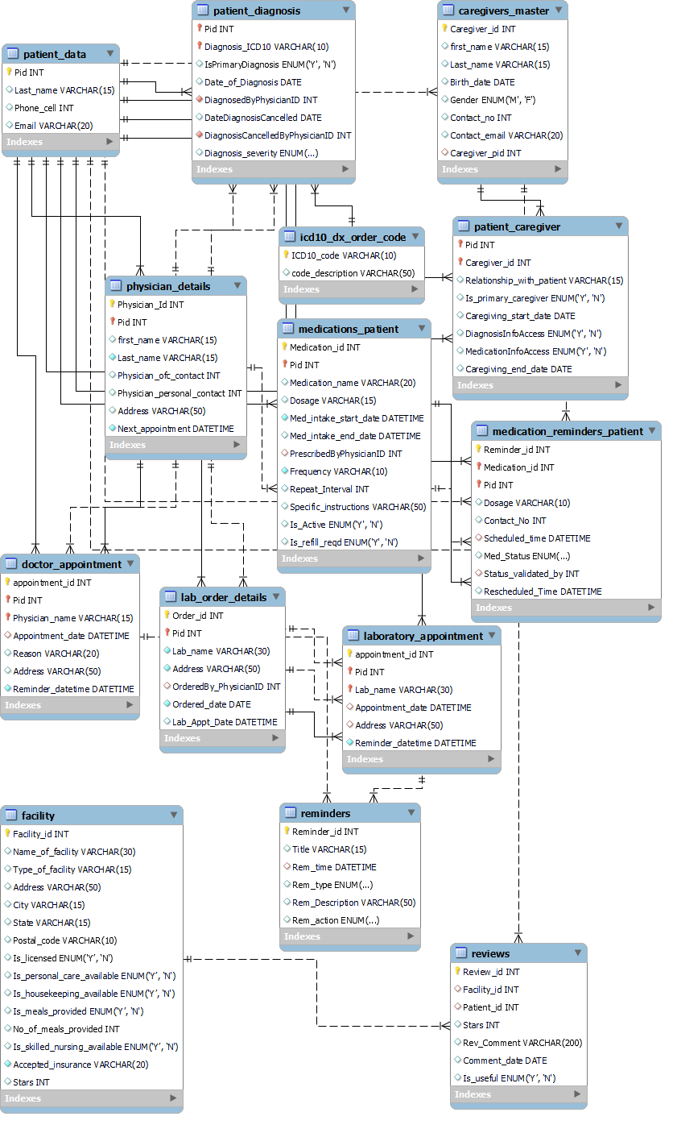

**Future scope**

The proposed solution can be further enhanced to include below features:

1. Import vital statistics from wearable and remote monitoring devices. Vital statistics like heart rate, blood glucose, body temperature, blood pressure, ECG, etc can be remotely monitored by the caregivers. In case of an irregular reading, the caregivers can follow up with the patient regarding their symptoms and take the patient to an emergency room if the need arises.
2. Add more filter criteria to the find assisted living feature so that the patient/family members can find a home catered to their needs.
3. Send alerts to caregivers in case of an unforeseen emergency situation like falling and unable to get up on their own, heart attack, etc.

**References:**

1. [Database Structure - OpenEMR Project Wiki (open-emr.org)](https://www.open-emr.org/wiki/index.php/Database_Structure)
2. [When to Move From Independent Living to Assisted Living | U.S. News (usnews.com)](https://health.usnews.com/best-assisted-living/articles/when-to-move-from-independent-living-to-assisted-living)
3. [Making Connections-Consumer Needs in an Aging America (acl.gov)](https://eldercare.acl.gov/Public/About/docs/n4a-data-report.pdf)
4. <https://healthjournalism.org/blog/2017/11/u-s-ranks-worse-in-elder-care-vs-other-wealthy-nations/>
5. [Demographic Changes and Aging Population – RHIhub Aging in Place Toolkit (ruralhealthinfo.org)](https://www.ruralhealthinfo.org/toolkits/aging/1/demographics#:~:text=Today%2C%20there%20are%20more%20than,increase%20by%20almost%2018%20million.)
6. [Calendars and Events  |  Calendar API  |  Google Developers](https://developers.google.com/calendar/api/concepts/events-calendars)